**INSTITUTE OF ENGINEERING**

ADVANCED COLLEGE OF ENGINEERING AND MANAGEMENT

Kupondole, Lalitpur

**(AFFILIATED TO TRIBHUVAN UNIVERSITY)**



**Subject: PROJECT MANAGEMENT**

**Submitted By: Submitted To:**

Name: Sameep Dhakal

Rabin Timalsina

Rajiv Dahal

Samrat Neupane

Dr. Pranita Upadhyaya

PROJECT MANAGEMENT PLAN

PROJECT INTEGRATION MANAGEMENT

Project Charter

|  |  |
| --- | --- |
| **Project Name** | Intelligent Re-commerce site with image and voice processing |
| **Focus Area** | Apply artificial intelligence in e-commerce website for better automation and customer satisfaction. |

## Prepared By:

|  |  |  |  |
| --- | --- | --- | --- |
| **Document Owners** | **Project Role** | **Work Division** | **Contact info** |
| Dr. Pranita Upadhyaya | Project Supervisor | Supervise the overall working of the project | pranitaupadhyaya@gmil.com |
| Rajeev Dahal | Project Manager | Consulting with CEO, stakeholders. manager, | Rajeev.074bct063@acem.edu.np |
| Rabin Timalsina | Project Team Member | Handle the voice processing department and recommendation | Rabin.074bct049@acem.edu.np |
| Sameep Dhakal | Project Team Member | Handle the web development department | Sameep.074bct063@acem.edu.np |
| Samrat Neupane | Project Team Member | Handles the image processing part. | Samrat.074bct064@acem.edu.np |

## Project purpose:

The team will identify and carry out necessary steps for developing e-commerce website that encompasses different fields of artificial intelligence. Our website will include theses fields:

* Image Procecssing
* Voice processing
* Product recommendation

Each team member will do appropriate e-commerce research to discover possible solutions for our new business. Team members will focus on building best e-commerce website using best tools of artificial intelligence available. Moreover, our intention is to replace the old fashioned e-commerce websites available in market.

## Project overview:

Our project’s mission is to develop new and successful AI based e-commerce website using various tools of Artificial intelligence such as CNN, Collaborative filtering. The site will use different models as Business to customer and Customer to customer models. We will use various available tools to make transactions and recommendations easier and fruitful.

## Project Objectives:

• To automatically crop and remove background of images inserted in website.

• To automatically analyze database for product recommendation and admin notification.

• To enable voice search using speech recognition

|  |  |
| --- | --- |
| Project Scope | * Website Development * Build AI models * Create business models |
| Milestones | * Project Planning * Project execution * Project closing |
| Time management | * Develop Gantt Chart * Develop Critical path Diagram |
| Cost Management | * Define cost of project |
| Potential Risks | * Unable to launch product in market * Server failure * Unable to reach more people * Unable to competein marler |
| Resource Management | * Hire Database manager * Hire Server Manager * Hire Market Expert |
| Procurement Management | * Data training server * Hosting Domain |
| Quality management | * Develop Benchmark * Fishbone Diagrams * Quality control- pareto analysis |

PROJECT SCOPE MANAGEMENT

## Project scope:

This field defines overall scope of our project:

|  |  |
| --- | --- |
| Goals |  |
| Design Goals: | **Visitor features:**  View home page  View most selling products  Search: voice and text  Browse products  View product details  View FAQ’s  Proceed to registration  **Registered customer Panel:**  Login  Search: voice and text  View recommended products Manage account my profile my orders  Buy product  Logout  **Registered seller panel:**  Login  View his/her most bought products  Manage account  My profile  Search: voice and text  Add items  Buy product  Logout  **Admin Panel**  Login  User Management  Product management  Price chart management  Order manager  Shipping management |
| Service goals:What will our website offer as product and services. | Product research by the project team, ie what are the most item being sold in various e commerce website, what are customers demanding and time based product sales(according to different festivals celebrated) |
| Design of Different models: B2C and C2C | Define estimated specifications , time , cost, schedule and personnel to integrate model into our website |
| Use of best available AI models | Project team will need to preform research on various tools that can automate our E-commerce website. Best tools for voice processing, image processing, and product recommendation are to be implemented |

Work Breakdown Structure:  
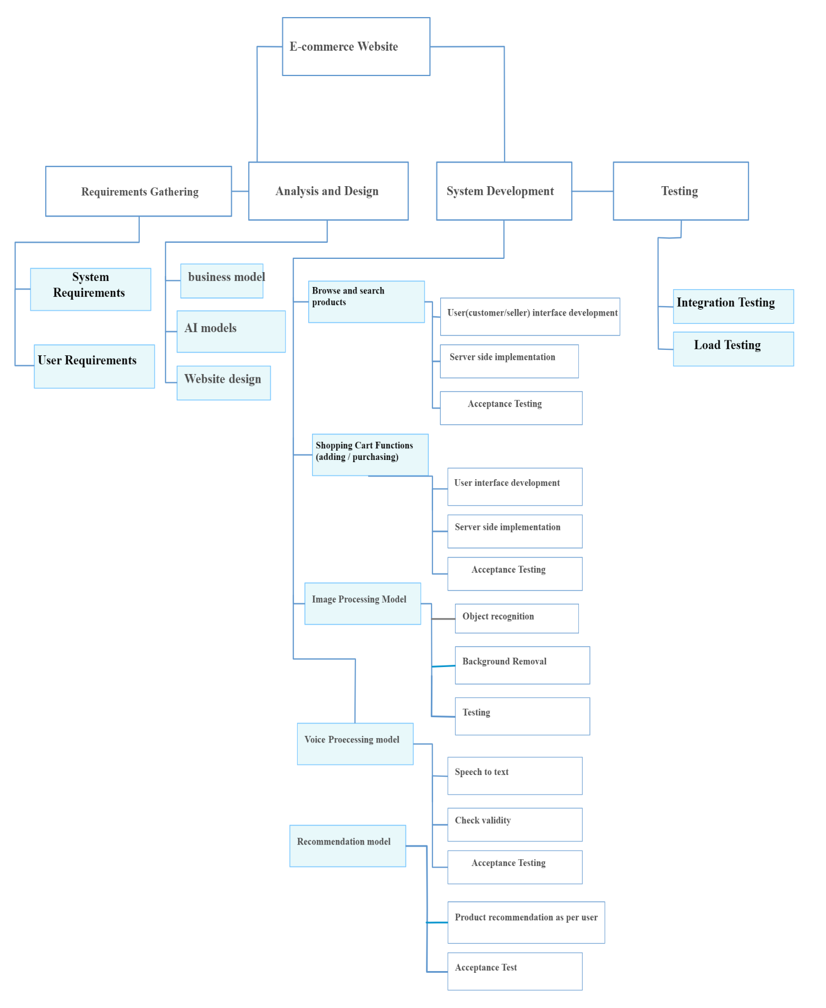

PROJECT TIME MANAGEMENT

## Project deliverables:

|  |  |  |
| --- | --- | --- |
| **Milestone** | **Date Estimate** | **Deriverables** |
| 1. Initiation_project Definition | May 15-july 10 | * define overall specs of website(image,voice processing, recommendation0 * Research Of business Models * Estimate the cost for making website * Estimate time and resources |
| 1. Execution-utilize ideas to create e-commerce business model | June 20-feb 10 | * Applying of business models (B2C and C2C) * Creating site based on research of AI tools * Testing our site |
| 1. Closing | Feb 10-March 30 | * Meet the needs of stakeholders * Make better website than available ones |

## Gantt chart:

## Critical path method:

|  |  |  |  |
| --- | --- | --- | --- |
| o | Description | precedents | Time |
| A | Research and consultation | - | 3 weeks |
| B | Image processing | A | 4 weeks |
| C | Login Page | A | 1 week |
| D | Voice Processing | B | 4 weeks |
| E | Product Recommendation | D | 4 weeks |
| F | User portal Design(admin/seller/customer) | C | 3 weeks |
| G | Product showcase design | F | 4 weeks |
| H | Backend Development | E,G | 10 weeks |
| I | Testing | H | 2 weeks |
| J | Presentation to stakeholders | I | 1 week |
| K | Launch | J | 4 weeks |

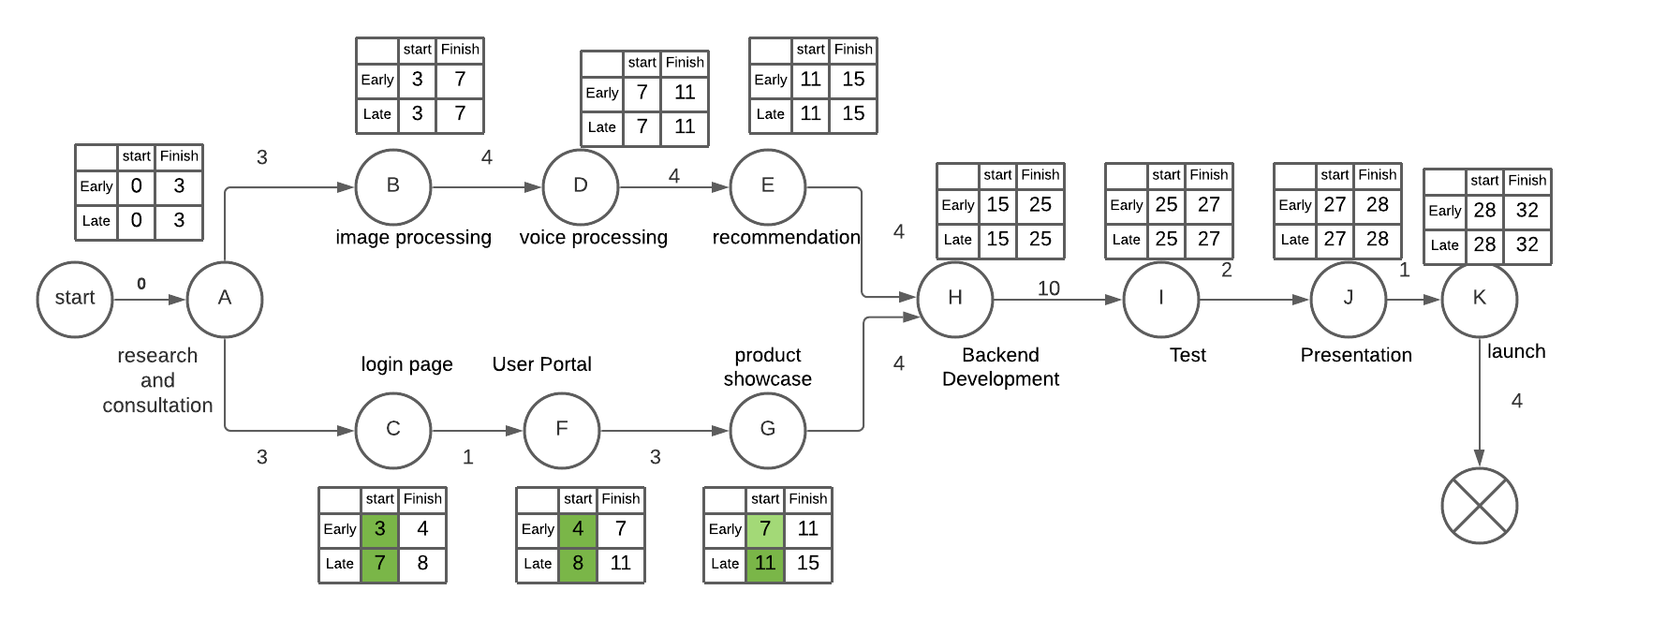

Here A,B,C,D,E,H,I,J,K are the critical events and non critical events have slack time 4 weeks.

PROJECT COST MANAGEMENT:

We first identified variable and fixed cost

**Fixed costs:**

* Internal server
* Developers computer
* Inter connections hardwares

**Variable cost:**

* Internal implementation labour
* Maintainence Contract
* Operational Contract
* Developers cost

**Hardware requirements:**

|  |  |  |
| --- | --- | --- |
| Particulars | Details | Amount |
| Server | Server to host our website, database server | 50000 |
| Pc for developments | 5 laptops | 400000 |
| Internet connection | Cables, terminals, hubs | 5000 |

**Software requirements**

|  |  |  |
| --- | --- | --- |
| Particulars | Details | Amount |
| Website design | A better ide forfrontend and backend | 50000 |
| Model training | Web based model training server Ie google colab, AWS | 20000 |
| Internet connectivity | Internet service with sufficient speed | 30000 |

**Other requirements:**

|  |  |
| --- | --- |
| Particulars | Amount |
| WWW server system | 20000 |
| Business registeration | 5000 |
| Annual Tax for Nepal Government | 5000 |

## Cost Analysis:



PROJECT COMMUNICATION MANAGEMENT

## Communication Planning:

Our team is consist of 4 members ,total communication channel will be 6 : (n(n-1)/2)

### Sample Stakeholders Communication analysis:

Communication will be in accordance of stakeholders tasks and concerns , flow of communication will be according to respective document presented

|  |  |  |  |  |  |  |  |
| --- | --- | --- | --- | --- | --- | --- | --- |
| **Stakeholders** | **Role/Intrest field** | **Document Name** | **impact** | **intrest** | **Document Format** | **Contact Person** | **Due** |
| Pranita Upadhyaya | Customer Management ,communication Supervisor | Weekly Status Report | High | High | Hard Copy | Rajiv Dahal | First of week |
| Sailesh Kafle | Voice to text and Its data collection | Weekly Status Report | Medium | High | Hard Copy | Rabin Timalsina | First of week |
| Sagar Timalsina | Image processing and and data collection | Weekly Status Report | High | Low | Hard Copy | Samrat Neupane | First of week |
| Sachin Thapa Magar | Web site creation and deployment | Weekly Status Report | Medium | Low | Hard Copy | Sameep Dhakal | First of week |
| Rupesh Lekhak | Customer management | Daily status report | medium | Low | Hard Copy | Sameep Dhakal | First of week |
| Raj Upreti | marketting | Weekly status report | medium | Low | Hard Copy | Sameep Dhakal | First of week |

### Media Choice Table

Way of communication is verified and chosen according to following table

**key:1 =Excellent 2=Adequate 3=Inappropriate**

|  |  |  |  |  |  |  |
| --- | --- | --- | --- | --- | --- | --- |
| **How well medium is suited to:** | **Hard Copy** | **Messenger** | **Voice Mail** | **E-mail** | **Zoom meeting** | **github** |
| Assessing Commitment | 3 | 3 | 3 | 3 | 1 | 3 |
| Programming Help | 3 | 1 | 3 | 2 | 2 | 3 |
| Resolving Misunderstanding | 3 | 2 | 1 | 3 | 3 | 3 |
| Maintaining Confidentiality | 2 | 2 | 1 | 2 | 3 | 3 |
| Sharing code | 3 | 2 | 3 | 2 | 3 | 1 |
| Building logics and modifying plans | 3 | 2 | 1 | 2 | 1 | 3 |

**Conclusion:**

Assessing Commitment via Zoom meeting,Programming Help via Messenger,Resolving Misunderstanding via voicemail,Maintaining Confidentiality via voice mail,v via github,Building logics and modifying plans via Zoom meeting

## Traceability Matrix:

Requirements traceability is the ability to connect requirements to other artifacts — such as different [types of software tests](https://www.perforce.com/resources/alm/types-software-testing) or bugs. It's used to track requirements — and prove that requirements have been fulfilled.

|  |  |  |  |  |  |  |  |
| --- | --- | --- | --- | --- | --- | --- | --- |
| **Ref. id** | **Main Requirement** | **Sub Requirement** | **Category** | **Description** | **Team** | **Status** | **Non functional requirement** |
| 1 | Voice to text and Image subtraction datasets preparation | Data cleaning and documentation | required | Through kaggle or manual preparation | Rabin,  Rajiv- Sameep Samrat | Started  (work in progress) | Usability, reusability,stability,availability |
| 2 | Data training and model preparation | Make exportable and reusable model | required | Using Sklearn libraries and tensor flow | Rabin,Rajiv-Sameep Samrat | to-do | Performance,Security,Usability,Portability,Availability |
| 3 | UI/UX design and front end development | Component based development | required | Use Reactjs and photoshop | Rabin,Rajiv-Sameep Samrat | Started  (work in progress) | Usability, reusability,stability,availability |
| 4 | API creation and data modeling | Should be based on Rest API | required | Use Nodejs and mongoDB | Rabin,Rajiv,Sameep Samrat | to-do | Performance,Security,Usability,Portability,Availability |
| 5 | Deployment | Use Heroku | optional | Use git and its tool | procurement | to-do | Performance,Security,Usability,Portability,Availability |
| 6 | SEO optimization | Use MOz-pro | optional | Optional can be done in spare time | procurement | to-do | performance,Availability,Usability |

RISK MANAGEMENT

The possible risk of our project are given below:

|  |  |  |  |  |  |  |  |  |  |
| --- | --- | --- | --- | --- | --- | --- | --- | --- | --- |
| Rank | Risk | Description | Category | Cause | Triggers | Potential response | Risk owner | probability | impact |
| 1 | Market risk | Many online e-commerce sites are already available. | commercial | Market competitiveness | Whenever we try to take a product to market. | 1.Use better technologies and interfaces.  2.Use of attractive UI | All | high | high |
| 2 | User interface | User may find our site hard to use | technical | Use of unfamiliar technologies | Searching and buying product from website | 1.Send a sample interface with a video to operate | Rajiv Dahal | medium | high |
| 3 | Change of technology | Maintenance could be tough due to change in technology | technical | Change in technology | When we need to update our system. | Update the version of programming language and don’t ignore warnings | Sameep dhakal | medium | medium |
| 4 | Model working phenomenon | Functionality of model over certain products could be not accurate | technical | Less no. of datasets during training | On recommendation, bg removing and voice searching | Re-training the model | Sameep Dhakal | medium | high |
| 5 | marketing | We may not convince people | social | We may not reach many people to make them understand about our project | When trying to reach multiple users | Use cognitive bias for marketing and better research of market fields. | Marketing executive. | high | high |
| 6. | Real time working of model | Dynamic changing of products can cause insensitive recommendation | technical | Real time data variation | Over recommendation part | Online and Batch training the model | Samrat Neupane | high | high |
| 7 | Server down due to more traffic | Server might not respond over heavy traffic | technical | Weak hosting platform | Entire site | Purchase the powerful hosting platform.  Improve security measures. | Rabin Timalsina | high | high |

PROCUREMENT MANAGEMENT PLAN

Procurement itself defines the materials or resources to purchase and acquire from outside the project team. Our team has concluded different resources to procure which are briefly listed and explained in the document below.

**Process flow**

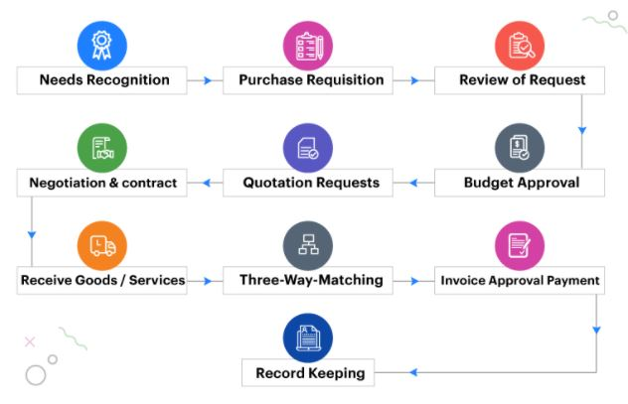

## Procurements

*Date: 24th July 2021*

|  |  |  |
| --- | --- | --- |
| Item | Description | Date |
| Data Training server | Used to train our different AI modes | July 2021 – February 2022 |
| Domain Hosting server | For hosting our website | March 2022 |
| Execution room | For future execution | April 2022 |

RESOURCE MANAGEMENT PLAN

## Responsibility Assignment Matrix

|  |  |  |  |  |
| --- | --- | --- | --- | --- |
| person  task | razeev | samrat | sameep | rabin |
| Background removal | A | R | R | A |
| Text to speech conversion | I | R | A | I |
| chatbot | R | C | R | A |
| Image recognition | R | A | C | R |
| Recommendation system | C | I | I | R |

Here,

Responsible= R

Accountable= A

Consulted= C

Informed= I

## Equipment Management:

|  |  |  |  |
| --- | --- | --- | --- |
| Description | Spec. | Quantity | Proposed supplier |
| Dell laptop | 8 gb RAM | 4 | personal |
| Cloud Training server | Unlimited | 4 | College management |
| Data resources | xx | xx | kaggle |

## Human Resource Management

### Internal Resources

|  |  |  |
| --- | --- | --- |
| Name | Role | Assigned Work |
| Dr. Pranita Upadhyaya | Project Supervisor | Supervise the overall working of the project |
| Rajeev Dahal | Project Manager | Consulting with CEO, stakeholders. manager, |
| Rabin Timalsina | Project Team Member | Handle the voice processing department and recommendation |
| Sameep Dhakal | Project Team Member | Handle the web development department |
| Samrat Neupane | Project Team Member | Handles the image processing part. |

### External Resources

|  |  |  |  |  |  |  |
| --- | --- | --- | --- | --- | --- | --- |
| **Description** | **Type** | **Reason** | **Timing to start** | **Bidder** | **Status** | **Comments** |
| SEO specialist | technical | To perform SEO after deployment | March 2022 | Rajiv Ranjan Sah | informed | Project will be given to SEO specialist on march 2021 |
| Data training Server | Resource | To train AI model | 15 Aug 2021 | Team members, AWS server | informed | Datasets will be ready and one time agreement |
| Domain and Hosting | Resource | To deploy and launch software | march 2022 | Er. Rupesh Lekhak | to-do | Software will be ready and must have fulfilled functional requirements |
| Testing and QA team | Technical | To test software and analyze its quality | 15 Nov 2021 | Er. UkeshThapa and team | informed | Software will be ready and should be in final stage to launch |
| Database Administrator | Technical | To extract necessary Info. and maintain database | 1st Jan 2022 | Raj Upreti and team | informed | Must login user info and traffic data & should submit analytical report to CEO |

QUALITY MANAGEMENT:

## Quality Planning:

Benchmarking:

Here as a benchmarking example we have taken the famous e-commerce website Amazon.

AMAZON:

Amazon offers a number of e-mail addresses to ensure customers can request for information that bothers them, and also to encourage suggestions and feedbacks. In addition to this, Amazon provides customers with telephone  services, therefore, users or customers can access the customer service representatives through the telephone 24 hours a day, and 7 days a week. Moreover, to ensure the quality of services provided by the customer service is prompt and professional enough to meet customer demands, Amazon has automated some specific tools utilized by its customer support staff and also constantly planning for future enhancements. (“Amazon Reports”)

Cause and effect diagram:

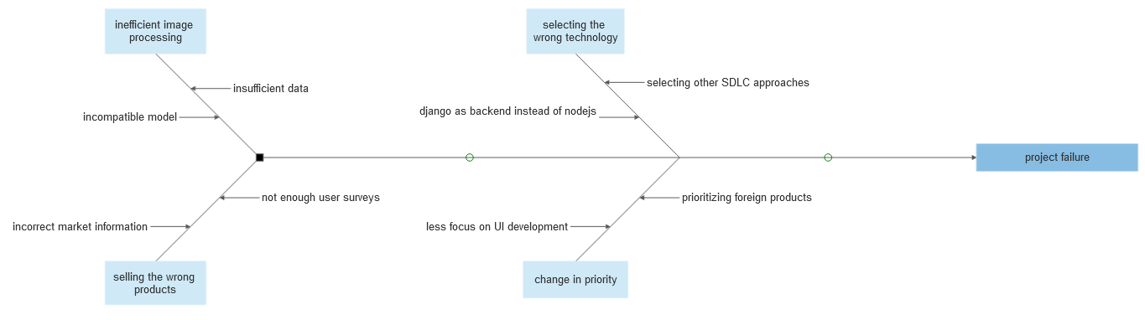

Fig:cause and effect(fishbone) diagram for e-commerce

## Quality Assurance

|  |  |  |  |  |  |  |  |
| --- | --- | --- | --- | --- | --- | --- | --- |
| Project Process | | Process Quality Standards/  Stakeholder Expectations | | Quality Assurance Activity | Frequency/Interval | | Who is Responsible |
| Requirement analysis | | Developers have completely understood project requirements. | | Peer review of software requirements specification. | | | weekly | All members. | |
| Set realistic time and budget estimates | | Minimum budget and time requirements | | Inspect project features | | | weekly | All members | |
| Programming the functionalities | | Project functionalities satisfies project requirements | | Verification and testing | | | weekly | All members | |
| Security features | | Project is secure and negates external attacks | | Proper security measures implementation | | | weekly | All members | |

## Quality Control

Pareto analysis:

It is the analysis based on the principle that “80% of our sales come from 20% of our clients” or “80% of complaints are from 20% of clients” also known as “80/20” rule.

The diagrammatical representation of pareto analysis is done through pareto diagrams. For our project we have analysed the error count to problem specifications:

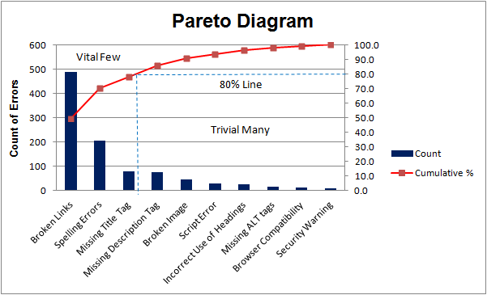

This concludes the project management plan of Intelligent recommerce website.